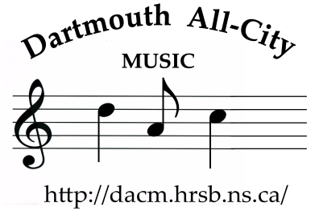

Dartmouth All-City Band Program

September 2016

Dear Parents and Guardians

The Dartmouth All-City Band program is part of the Halifax Regional School Board and is largely supported by the municipality’s supplementary funding program. Together, they cover our facilities, teachers and some of our operational needs. Our registration fees and fundraising under the auspices of the Dartmouth Band Parents Association (DBPA) help pay for additional expenses such as assistant directors, musical scores, student workshops, support to students in need, and the Dartmouth Band Parents Association Scholarship for a graduating student pursuing a degree or diploma in music.

This upcoming fall, we will undertake our second online auction. The first one, which was held last year, was not only successful, but it was very fun and exciting for all the bidders! We want this one to be bigger, better, and lots of fun for all. With your help, we can achieve this. So, once again, we are seeking support from family, friends, workplaces, or any other source for donations of items for our online auction. That’s about the extent of the work on your end. The Dartmouth Band Parents Association will take it from there. However, we are hoping that all of you and your auction-loving friends will join the bidding wars!

All donations are greatly appreciated—personal or business items, gift cards, etc. Please give some consideration to soliciting and collecting auction items for submission to the Dartmouth Music Centre by October 27th. The more interesting items we get the better. The auction will be in November, with firm dates TBA.

We look forward to your participation in this exciting endeavour. Thank you for your continued support in our wonderful music programs.

Sincerely,

Pam Paddock
Coordinator, Dartmouth All-City Music Program
ppaddock@hrsb.ca
http://dacm.hrsb.ns.ca

